PERSONAL INFORMATION | Karol-Julien WILD
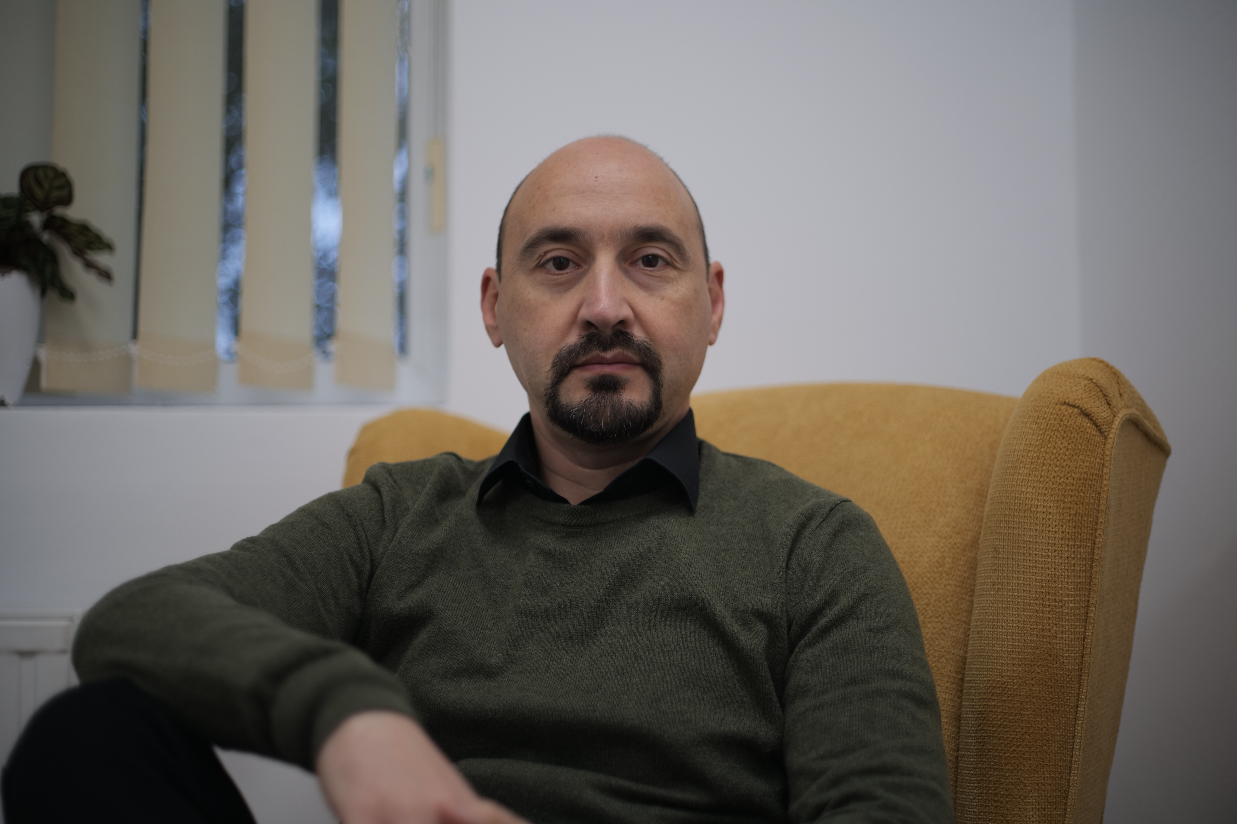
 | Sex Male | Date of birth | Nationality Romanian

POSITION  STUDIES APPLIED FOR | University Lector

WORK EXPERIENCE

09.2008 - present | Psychotherapist - Coach
09.2008 - present | Wild & Associates - Private Practice (Arad, Romania, www.wildassociates.ro)
09.2008 - present | - Psychotherapy  - Executive Coaching  - Workshops, on themes like: Emotional Regulation Efficacy
09.2008 - present | Business or sector Mental Health
12.02.2026 - present  10.2013 - 08.2021 | University Assistant
12.02.2026 - present  10.2013 - 08.2021 | “Vasile Goldis” Western University of Arad, Psychology Department (Arad, Romania, www.uvvg.ro)
12.02.2026 - present  10.2013 - 08.2021 | - I held the following seminars:  - Psychometrics and Psychological Assessment  - Fundaments in Psychology  - Psychiatric interviewing and assessment  - Psychotherapy  - Introduction in Research Methodology  - Communication and the Client -Therapist Relation
12.02.2026 - present  10.2013 - 08.2021 | Business or sector Education
04.2009 - 06.2016 | Senior Consultant
04.2009 - 06.2016 | CCS Corporate Consulting Services (Luxemburg, Bucharest, Romania, https://ccsint.com/)
04.2009 - 06.2016 | - Psychological Interventions in Crisis Situation  - Anger Management Workshops  - Creativity Training Workshops  - Counselling & Coaching
04.2009 - 06.2016 | Business or sector Consulting & Mental Health
02.2004 - 08.2008 | Psychotherapist under supervision
02.2004 - 08.2008 | International Institute for the Advanced Studies of Psychotherapy and Applied Mental Health (Cluj Napoca, Romania, www.psychotherapy.ro)
02.2004 - 08.2008 | - Psychotherapy
02.2004 - 08.2008 | Business or sector Mental Health

EDUCATION AND TRAINING

10.2017 - 09.2024 | PhD in Psychology
10.2017 - 09.2024 | Babes-Bolyai University, Doctoral School of Applied Cognitive Psychology (Cluj-Napoca, Romania, https://psychology.psiedu.ubbcluj.ro/en/)
10.2017 - 09.2024 | - Thesis is entitled: Cost of Emotional Regulation on Life Quality  - Magna cum Laude
10.2008 - 07.2010 | Master (MA)
10.2008 - 07.2010 | Babes-Bolyai University, Department of Psychology (Cluj-Napoca, Romania, https://psychology.psiedu.ubbcluj.ro/en/)
10.2008 - 07.2010 | - Master in Psychological Techniques for Behaviour Control and Human Potential Development  - My Dissertation was entitled: Efficacy of an Acceptance and Commitment Training Program on Anger and Job life Satisfaction
02.2004 - 08.2008 | Formal Training in Cognitive - Behaviour Psychotherapy (REBT)
02.2004 - 08.2008 | International Institute for the Advanced Studies of Psychotherapy and Applied Mental Health (Cluj Napoca, Romania, www.psychotherapy.ro) & Albert Ellis Institute (New York, USA, https://albertellis.org/)
02.2004 - 08.2008 | - As a result of the formal training I was certified as Cognitive-Behaviour Psychotherapist by the Romanian Psychological Board. No.01808, https://copsi.ro
10.1999 - 07.2003 | Bachler (BA)
10.1999 - 07.2003 | Babes-Bolyai University, Department of Psychology (Cluj-Napoca, Romania, https://psychology.psiedu.ubbcluj.ro/en/)
10.1999 - 07.2003 | - License as Psychologist  - My Licences was entitled: Religious Orientations and Mental Health

PERSONAL SKILLS

Mother tongue(s) | Romanien
Other language(s) | UNDERSTANDING |  | SPEAKING |  | WRITING
Other language(s) | Listening | Reading | Spoken interaction | Spoken production
German | C2 | C2 | C2 | C2 | C1/C2
 | Deutsches Sprachdiplom - Zweite Stufe (C1) , ausgegeben vom Ständige Konferenz der Kultusministerium der Länder in der Bundesrepublik Deutschland, 1997
English | B2 | B3 | A2/B1 | A2/B1 | A2
Levels: A1/A2: Basic user - B1/B2: Independent user - C1/C2 Proficient user
Common European Framework of Reference for Languages

Digital competence | JAMOVI, R, SPSS, Office Suite, Content Creation apps as well on Mac as also on PC

Research Methodology Intrests | - interested in Bayesian statistics and theory (beginner)  - interested in Experience Sampling Methods research and other ecological methods

Driving licence | B

ADDITIONAL INFORMATION

Management Projects  Research Projects  Presentations / Conferences  References | - Project Manager of the Human Resources Development Project "Human Resource - Resource that represents us" PHARE 2005, budget 35.000 EUR.  - 2014 -2015 Development of human resources - doctoral and postdoctoral students - for research excellence in the fields of health and biotechnologies(DPD) POSDRU/ 159/1.5/S/141531  - 2011 - 2012 Member in the research group affiliated to: (a) the International Coaching Institute of the Department of Clinical Psychology and Psychotherapy, (b) Babes-Bolyai University, Cluj-Napoca, and (c) the Virtual Reality Platform.The project targets topics that are part of the international research mainstream in the study of: The effectiveness of coaching techniques applied in business, for increasing professional performance and employee well-being.  - Karol-Julien WILD, Chiralina LIMOTA, Oana DAVID (2014) The efficiency of an "ACT" Stress Management Program on Anger and Job Satisfaction. : 1st International Congress of Cognitive Behavioral Coaching - ICCBC 2014, June. 2014, Cluj-Napoca  - Karol-Julien WILD, Chiralina LIMOTA, Delia PODEA (2014) Managing the double Agenda in Executive Coaching, 1st International Congress of Cognitive Behavioral Coaching - ICCBC 2014, iun.2014, Cluj-Napoca  - Professor dr. Adrian N. Opre, PhD. - Dean of the Department of Psychology at Babes Bolyai University and the scientific coordinator of my doctoral thesis. Email: adrianopre@psychology.ro, Phone: +40 744 555 158  - dr. Bianca Macavei, PhD. - psychotherapy supervisor during my formal training in psychotherapy. Email. biancamacavei@gmail.com, Phone: +40 744 362 123

