LISTA CU REALIZĂRILE ȘTIINȚIFICE

Dr. Foia Cezar-Ilie

Medic rezident an II Ortopedie-Traumatologie_ Spitalul Clinic Județean de Urgențe Sf. Spiridon, Iași
Doctorand domeniul Medicină – Universitatea de Medicină și Farmacie „Grigore T. Popa” din Iași

- Articole publicate in extenso în reviste cotate ISI_Clarivate

Autor principal

- Foia CI, Coman CG, Chabot C, Gardikiotis I, Trandafirescu M, Pavel LL, Sîrbu PD, Mititelu- Tartau L, Voloșeniuc T. In Vivo Biocompatibility Evaluation of Norfloxacin-Loaded Chitosan Nanofibers and Boronic Aldehyde-Functionalized Derivatives in Rat. The Medical-Surgical Journal. 2026; 130(2). 345-354.doi:10.22551/MSJ.2026.02.14IF=0,2 https://www.revmedchir.ro/index.php/revmedchir

- Cosovanu EO, Foia CI*, Tamba BI, Szilagyi A, Costachescu I, Stanciu GD, Pavel LL, Mititelu- Tartau L. Anti-Inflammatory Efficacy of Nsaids and Their Combinations with Antibiotics in a Rat Model of Acute Carrageenan-Induced Inflammation. The Medical-Surgical Journal. 2026;130(1):128-137. IF=0,2. https://www.revmedchir.ro/index.php/revmedchir/article/view/3334

- Bojan A, Vladeanu MC, Pricop C, Bararu-Bojan I*, Foia CI*, Giusca SE, Iliescu D et al. Clinical and molecular signitures of gallblader lesions: Insights into Metabolic and Inflammatory Pathways. Diagnostics. 2026. 16(10), 1480. IF=3,3. https://doi.org/10.3390/diagnostics16101480

- Cosovanu EO, Foia CI*, Ilie MG, Szilagyi A, Stanciu GD, Tamba BI, Pavel LL, Tartau LM. Enhanced Anti-Inflammatory Efficacy of Nsaid–Antibiotic Combinations in Experimental Subacute Inflammation. The Medical-Surgical Journal. 2025;129(4):705-714. IF=0,2.
https://www.revmedchir.ro/index.php/revmedchir/article/view/3286

Coautor

- Paceana M-A, Tartau LM, Boboc IKS, Oancea CN, Berbecaru-Iovan A, Foia CI, Tartau CG, Bogdan M. Diabetes Mellitus and Stroke: Pathophysiological Connections and Therapeutic Potential of GLP-1 and GLP-1/GIP Receptor Agonists. Pharmaceutics. 2026;18(5):620. IF=5,5 https://doi.org/10.3390/pharmaceutics18050620
- Nichitean G, Cosovanu ET, Bejan O, Ionescu S, Ivanov D, Damian C, Socolov D, Grigore M, Dimitriu CD, Foia C, et al. Salivary Prevalence of Four Oral Pathogens in Postpartum Women in Northeast Romania: An Exploratory Cross-Sectional Study. Pathogens. 2026; 15(5):507. IF=3,3. https://doi.org/10.3390/pathogens15050507

- Cosovanu EO, Bogdan M, Coman EA, Foia CI, Tartau CG, Cosovanu ET, Petroaie AD, Pavel LL, Pelin AM, Tartau LM. Renal Risk Awareness and Use Patterns of NSAIDs and Antibiotics in Primary Care Patients from North-Eastern Romania. Medicina (Kaunas). 2026;62(3):594. IF=2,4.
https://doi.org/10.3390/medicina62030594

- Murariu A, Baciu ER, Onică CA, Frățilă DN, Brânzan RC, Bobu L, Foia CI, Lupu CI. Assessment of Dental Students' and General Dentistry Residents' Knowledge Regarding the Management of Anaphylactic Shock in the Dental Practice: A Single-Centre Study in Romania. Dentistry Journal. 2026;14(2):75. IF=3,1. https://www.mdpi.com/2304-6767/14/2/75

- Baciu ER, Onică CA, Murariu A, Gelețu GL, Lupu CI, Foia CI, Onică N. From Digital Planning to Personalised Surgical Integration: Total Temporomandibular Joint Prosthesis and Patient-Specific Plates in Bimaxillary Orthognathic Surgery. Prosthesis. 2026;8(4):41. IF=4,5.
https://doi.org/10.3390/prosthesis8040041

- Surdu A, Foia CI, Luchian I, Trifan D, Budala DG, Scutariu MM, Ciupilan C, Puha B, Tatarciuc D. Telemedicine and Digital Tools in Dentistry: Enhancing Diagnosis and Remote Patient Care. Medicina (Kaunas). 2025;61(5):826. IF=2,4. https://www.mdpi.com/1648-9144/61/5/826
- Murariu A, Bobu L, Gelețu GL, Stoleriu S, Iovan G, Vasluianu RI, Foia CI, Zapodeanu D, Baciu ER. The Impact of Mobile Applications on Improving Oral Hygiene Knowledge and Skills of Adolescents: A Scoping Review. Journal of Clinical Medicine. 2025;14(9):2907. IF=2,9. https://doi.org/10.3390/jcm14092907

- Koush AA, Mititelu-Tartau L, Foia CI, Pauna A-MR, Buca BR, Popovici IA, Pavel LL, Plesea- Condratovici C, Stefanescu B. Chitosan-Stabilized Lipid Vesicles for Sustained Release and Prolonged Analgesic Effects of Indomethacin in a Somatic Pain Model in Mice. The Medical- Surgical Journal. 2025;129(1):178-187. IF=0,2. https://www.revmedchir.ro/index.php/revmedchir/article/view/3155

- Leferman CE, Ochiuz L, Stoica L, Minea B, Foia CI, Constantinescu V, Olariu O, Ciubotaru AD, Stoica BA. Impact of Manganese Coordination and Cyclodextrin-Assisted Formulation on Thiabendazole Dissolution and Endothelial Cell Migration. Germs. 2025; 16(1):1. IF=1,7.
https://doi.org/10.3390/germs16010001
- Surdu AE, Trifan D, Foia CI, Sufaru I-G, Cioloca DP, Scutariu MM. Impact of Smoking on Oral Status in Young Adults: a Comparative Analysis between Conventional Cigarettes and Heated Tobacco Products. Romanian Journal of Oral Rehabilitation. 2025;17(1):411-419. IF=1,1 http://rjor.ro/wp-content/uploads/2025/04/IMPACT-OF-SMOKING-ON-ORAL-STATUS-IN-YOUNG-ADULTS-A-COMPARATIVE-ANALYSIS-BETWEEN-CONVENTIONAL-CIGARETTES-AND-HEATED-TOBACCO-PRODUCTS.pdf
- Popovici IA, Botnariu EG, Giuvara R, Agop-Forna D, Foia CI, Surdu A, Cioloca D, Gheorghe L. The Influence of Socio-Demographic Factors on Knowledge and Perceptions of Dental Implants. Romanian Journal of Oral Rehabilitation. 2025;17(1):485-495. IF=1,1. https://rjor.ro/wp-content/uploads/2025/04/THE-INFLUENCE-OF-SOCIO-DEMOGRAPHIC-FACTORS-ON-KNOWLEDGE-AND-PERCEPTIONS-OF-DENTAL-IMPLANTS.pdf

- Abu Koush A, Popa EG, Pricop DA, Nita L, Foia CI, Pauna AR, Buca BR, Pavel LL, Mititelu- Tartau L. Enhanced Stability and In Vitro Biocompatibility of Chitosan-Coated Lipid Vesicles for Indomethacin Delivery. Pharmaceutics. 2024;16(12):1574. IF=5,5.
https://doi.org/10.3390/pharmaceutics16121574

- Mititelu-Tartau L, Bogdan M, Pavel LL, Rezus C, Foia CI, Dima N, Gurzu IL, Pelin AM, Buca BR. Anxiolytic-like Activity, Antioxidant Properties, and Facilitatory Effects on the Short- Term Memory Retention of Molsidomine in Rats. Life (Basel). 2024;14(3):306. IF=3,4. https://doi.org/10.3390/life14030306

- Toma V, Băsăscu T, Cenușă C, Savin C, Sîrghe A, Șerban-Pintiliciuc V, Adumitroaie A, Foia C, Mihalaș E, Marciuc D, Golovcencu L. Behavioural Management Of Children With Various Intellectual Disabilities – A Practical Guide. Romanian Journal of Oral Rehabilitation. 2023; 15(3):482-487. IF=0,6. https://www.rjor.ro/wp-content/uploads/2023/10/BEHAVIOURAL-MANAGEMENT-OF-CHILDREN-WITH-VARIOUS-INTELLECTUAL-DISABILITIES-–-A-PRACTICAL-GUIDE1.pdf

- Golovcencu L, Răschip L, Mirt D, Faur R, Savin C, Sîrghe A, Adumitroaie A, Foia C, Muntean A, Anistoroaei D, Toma V. Impact of Mouth Breathing on the Development of the Dento- Maxilo-Facial Complex in Children and Adolescents. Romanian Journal of Oral Rehabilitation. 2023;15(4):387-394. IF=0,6. http://rjor.ro/wp-content/uploads/2023/12/IMPACT-OF-MOUTH-BREATHING-ON-THE-DEVELOPMENT-OF-THE-DENTO-MAXILO-FACIAL-COMPLEX-IN-CHILDREN-AND-ADOLESCENTS.pdf

- Articole publicate in extenso în reviste indexate BDI

Autor principal

- Foia CI, Cosovanu EO, Ghemiș L, Tarțău AM, Cioloca D, Ciubotaru AD, Adumitroaie AE. Exploring Potential Correlations Between Oxidative Stress Markers and Inflammatory Pivotal Factors in Children with Hematological Malignancies. Current Health Sciences Journal. 2026;52(1):55-64. https://www.chsjournal.org/article/52/1/7/
https://www.chsjournal.org/indexing/

- Burculeț R-C, Ciurcanu OE, Scutariu MM, Toma V, Fînariu A-I, Foia CI. Potential Role of Chromium in Oral and Periodontal Health in Children with Type 1 Diabetes Mellitus. Romanian Journal of Oral Rehabilitation. 2025;17(4):33-41. https://rjor.ro/potential-role-of-chromium-in-oral-and-periodontal-health-in-children-with-type-1-diabetes-mellitus/
https://openurl.ebsco.com/c/t4a2lo/results?limiters=DT%3A2021-&bquery=Potential+Role+of+Chromium+in+Oral+and+Periodontal+Health+in+Children+with+Type+1+Diabetes+Mellitus&page=1&link_origin=www.google.com

- Toma V, Burduloi DA, Pîrlog A, Mihalaș E, Vasîlca-Gavrilă L, Foia C*, Spinei A, Adumitroaie A. Practical Approaches to Behavior Support in Children with Special Mental Health Needs – A Literature Review. Romanian Journal of Oral Rehabilitation. 2025;17(4):197-203.
https://www.rjor.ro/wp-content/uploads/2026/01/PRACTICAL-APPROACHES-TO-BEHAVIOR-SUPPORT-IN-CHILDREN-WITH-SPECIAL-MENTAL-HEALTH-NEEDS-–-A-LITERATURE-REVIEW.pdf
https://openurl.ebsco.com/c/t4a2lo/results?limiters=DT%3A2021-&bquery=Practical+Approaches+to+Behavior+Support+in+Children+with+Special+Mental+Health+Needs+–+A+Literature+Review&page=1&link_origin=www.google.com

Coautor

- Ciubotaru AD, Leferman C-E, Foia C, Cojocaru K, Minea B, Goriuc A, Cioloca D. Pharmacological Versus Psychological Treatment in Odontophobia: The Right Approach. Romanian Journal of Medical and Dental Education. 2023;12(6):30-38. https://journal.adre.ro/wp-content/uploads/2024/01/4.-PHARMACOLOGICAL-VERSUS-PSYCHOLOGICAL-TREATMENT-IN-ODONTOPHOBIA-THE-RIGHT-APPROACH.pdf

- Comunicări științifice orale în cadrul conferințelor naționale

- Foia CI, Roșu VC, Carciuc DG, Gheorghevici TS, Popa P, Poroch M, Matei DE, Balan C, Puha B. Surgical management of complex periprosthetic hip fractures - case report. Zilele Spitalului de Recuperare Iași, martie 2026. https://recuperareiasi.ro/program-stiintific/

- Roșu VC, Foia CI, Carciuc DG, Gheorghevici TS, Popa P, Poroch M, Matei DE, Balan C, Puha B. Luxația cronică de cot – abordare chirurgicală și rezultate funcționale într-un caz clinic. Zilele Spitalului de Recuperare Iași, martie 2026. https://recuperareiasi.ro/program-stiintific/

IV. Proiecte de cercetare în derulare
- Teză de doctorat (2024–2027)
Titlu: Cercetări privind dezvoltarea și investigarea unor nanosisteme terapeutice: de la testare experimentală la perspective de aplicare în gonartroză

Coordonator: Prof. Dr. Mititelu-Tarțău Liliana; Școala Doctorală UMF „Grigore T. Popa” Iași
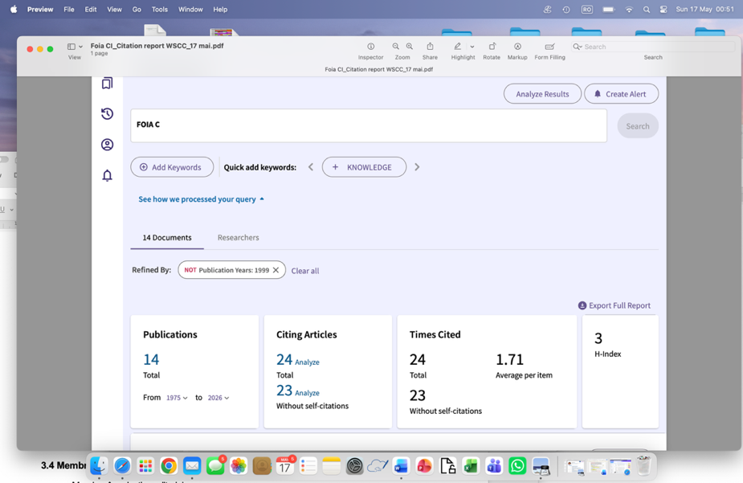 29.05.2026

