LISTA PUBLICAŢIILOR ŞTIINŢIFICE

Dr. ILLE Codruța-Eliza, DMD, PhD

Citation Report, h-index - Web of Science Core Collection (Iunie 2026)
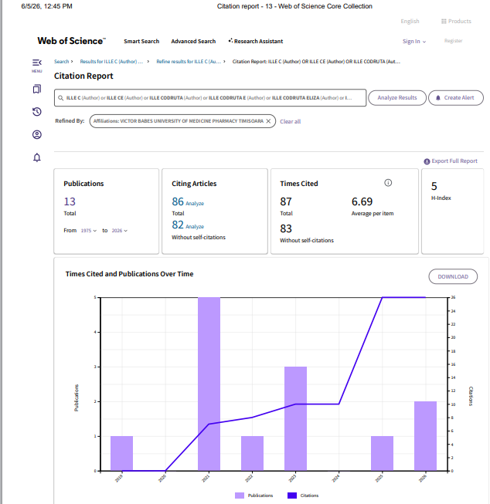

TEZĂ DOCTORAT

Diplomă de doctor în Medicină Dentară, conf. OMEN nr. 4155 din 10.05.2023
Titlul tezei: Cercetări asupta materialelor şi tehnicilor digitale pentru evaluarea şi tratamentul minim invaziv al uzurilor dentare
Coordonator ştiintific: Prof.Univ.Dr. Jivănescu Anca
Data susţinerii: 17.02.2023
- CAPITOLE DE CARTE – publicate în editură internaţională

  - Jivanescu A, Rotar R, Ille, C. Chairside CAD/CAM Restorations. In: Advances in Dentures - Prosthetic Solutions, Materials and Technologies, IntechOpen, London, UK, 2024.DOI: 10.5772/intechopen.114090.

PUBLICAŢII

- Articole publicate in extenso indexate ISI Web of Knowledge

  - (Coţ), D.-E.P.; Kiş, A.; Stroia, C.; Talpoş-Niculescu, I.-C.; Popovici, R.-A.; Ille, C.-E.; Sallai, A.M.; Anton, A.; Moacă, E.-A.; Muntean, E.D.; Suciu, M. New Insights into the Antimicrobial and Wound-Healing Properties of Turmeric-Powder-Derived Curcuma longa Extracts for Oral-Health-Oriented Applications. Biomedicines 2026, 14, 1078, https://doi.org/10.3390/biomedicines14051078. (I.F. 3,9)
  - Pitic, D.-E.; Popovici, R.-A.; Ille, C.-E.; Talpoş-Niculescu, I.-C.; Chevereşan, A.; Pop,
- ; Dănilă, A.-I.; Muntean, E.D.; Boantă, I.D.; Kis, A.; Stroia, C. Curcumin-Based Nanoformulations for Oral Health: Mechanistic Insights, Antimicrobial Efficacy, and Future Clinical Perspectives. Biomedicines 2026, 14, 815. https://doi.org/10.3390/biomedicines14040815 ( I.F. 3,9)
- Ille, C.-E.; Jivănescu, A.; Pop, D.; Stoica, E.T.; Flueras, R.; Talpoş-Niculescu, I.-C.; Cosoroabă, R.M.; Popovici, R.-A.; Olariu, I. Exploring the Properties and Indications of Chairside CAD/CAM Materials in Restorative Dentistry. J. Funct. Biomater. 2025, 16,
46. https://doi.org/10.3390/jfb16020046 (I.F. 5,2)
- Ille, C.E.; Moacă, E.-A.; Suciu, M.; Barbu-Tudoran, L.; Negruțiu, M.-L.; Jivănescu, A. The Biological Activity of Fragmented Computer-Aided Design/Manufacturing Dental Materials before and after Exposure to Acidic Environment. Medicina 2023, 59, 104. https://doi.org/10.3390/medicina59010104 (I.F. 2,4)
- Ille, C., Moacă EA, Pop D, Goguță L, Opriș C, Pîrvulescu IL, Avram L, Faur A, Jivănescu, A. Compressive strength evaluation of thin occlusal veneers from different CAD/CAM materials, before and after acidic saliva exposure. Odontology. 2023 111(2):360-374. Epub 2022 Sep 12. Erratum in: Odontology 2023, 111(2):375. https://doi.org/10.1007/s10266-022-00741-5 (I.F. 2,4)
- Goguta, L; Frandes, M; Candea, A; Ille, C; Jivanescu, A. Impact of unilateral removable partial dentures versus removable partial dentures with major connector on oral health-related quality of life of elder patients: a clinical study; BMC ORAL HEALTH 2023, 23(1), Article Number 182. https://doi.org/10.1186/s12903-023-02870-x (IF 1,32)
- Pîrvulescu, I.L.; Pop, D.; Moacă, E.-A.; Mihali, C.-V.; Ille, C.; Jivănescu, A. Effects of Simulated Gastric Acid Exposure on Surface Topography, Mechanical and Optical Features of Commercial CAD/CAM Ceramic Blocks. Appl. Sci. 2021, 11, 8703. https://doi.org/10.3390/app11188703 (I.F. 2,5)
- Goguta, L., Lungeanu D, Ille, C., Rotar R, Leretter M, De Wever B, Jivanescu A, Topalā
F. Efficacy of PerioTabs, a NitrAdine-based gingiva brushing solution, on periodontally affected patients treated with fixed partial dentures: a randomized controlled study. Quintessence Int. 2021, 52(4):292-298. https://doi.org/10.3290/j.qi.b912689 (I.F. 1,5)
- Ille, C.E., Faur A.B., Rotar R.N., Pîrvulescu I.L., Jivănescu A. Intraoral scanning for early dental erosion assessment - An in vitro study. Romanian Journal of Oral Rehabilitation (RJOR) 2021, 13(1), 194-201 (I.F. 0,6)
- Pîrvulescu, I., Ille, C., Rotar R., Goguță L., Cîrligeriu L., Jivănescu A. Color changes of different CAD/CAM blocks after immersion in usual beverages. Romanian Journal of Oral Rehabilitation (RJOR). 2021, 13(1), 341-347 (I.F. 0,6)
- Avram,L., Goguta, L., Galatanu S.-V., Opris C., Ille, C., Jivanescu A. Material Thickness Influence on Fracture Load of Polymer Infiltrated Ceramic Network CAD/CAM Restoration, Materiale Plastice (Mater. Plast.) 2021, 58(2), 8-17 https://doi.org/10.37358/MP.21.2.5473 (I.F. 0,5)
- Rotar, RN, Jivanescu A, Ille, C., Podariu AC, Jumanca DE, Matichescu AM, Balean O, Rusu LC. Trueness and Precision of Two Intraoral Scanners: A Comparative In Vitro Study. Scanning. 2019, Article number 1289570. https://doi.org/10.1155/2019/1289570 (I.F 1,11)

- Articole publicate in extenso indexate BDI

- Ille, C., Rotar, R, Jivănescu, A. Full Mouth Rehabilitation of Tooth Wear using Digital and Conventional Technologies. Research and Clinical Medicine (ResClinMed). 2021; V(IV).
- Rotar, R, Ille, C., Jivanescu, A. Digital and Conventional Approach for the Treatment of Severe Anterior Dental Wear in a Type 2 Diabetes. Romanian Journal of Diabetes Nutrition and Metabolic Diseases. 2020; 27(3):289-293. https://doi.org/10.46389/rjd-2020-1042
- Rotar, R, Malaescu R, Ille, C., Pirvulescu, I, Jivanescu, A. Is CAD/CAM Technology a valuable tool for prosthodontics residents in tooth preparation assessment? Research and Clinical Medicine (ResClinMed). 2020; IV(III).

Lucrări prezentate la manifestări ştiinţifice naţionale/internaţionale

  - Ille, C.-E., Rotar, R.N., Jivanescu, A., Full Mouth rehabilitation of tooth wear using digital and conventional techniques, International Scientific Conference in Dentistry Novi Sad - 2nd, 3rd April 2022 – Oral Presentation.

